**ECO423 ASSIGNMENT 2**

**NAME - PRAGYA PURI**

**ROLL- 230767**

**1. Which stock do you believe provides the most attractive investment**

**opportunity for the Cavalier Fund? Why?**

We have to identify the most attractive investment opportunity among four stocks—**Delphi, Groupon, Kellogg, and Kinross Gold**. For that, I have analyzed the risk-adjusted returns (Sharpe Ratio) and theoretical fair returns (CAPM) to make the best choice.

**RISK FREE RATE AND MARKET PREMIUM**

**1. Risk-Free Rate (Rf)**

We use the 10-year U.S. Treasury yield as the standard risk-free rate.

10-year Treasury Yield = **2.34% annually**(Apr 6, 2017)

**2. Market Risk Premium (MRP)**

From the monthly return data for S&P 500:

* Mean monthly market return ≈ **1.04%**
* Annualized return: **11.6%**

Market Risk Premium=11.6%−2.34%=**9.26%**

**GIVEN DATA**

|  |  |  |  |
| --- | --- | --- | --- |
| **Stock** | **Anticipated Return** | **Standard Deviation (σ)** | **Beta (β)** |
| Delphi | 9.1% | 24.6% | 1.29 |
| Groupon | 9.3% | 67.1% | 1.44 |
| Kellogg | 4.6% | 14.6% | 0.54 |
| Kinross | 8.4% | 65.0% | 0.31 |

**CALCULATION OF SHARPE RATIO AND CAPM RETURNS**

|  |  |  |  |
| --- | --- | --- | --- |
| **Stock** | **Anticipated Return** | **CAPM Return** | **Sharpe Ratio** |
| **Delphi** | 9.10% | 14.28% | 0.27 |
| **Groupon** | 9.30% | 15.46% | 0.10 |
| **Kellogg** | 4.60% | 6.83% | 0.15 |
| **Kinross** | 8.40% | 5.77% | 0.09 |

**Delphi Automotive**

* Anticipated Return (9.10%) is below the CAPM Return (14.28%), suggesting underperformance relative to expected market return.
* However, it has the highest Sharpe Ratio (0.27), indicating the best return per unit of risk.
* Delphi balances risk and reward well, making it a strong choice for portfolios seeking growth with controlled risk.

**Groupon**

* Anticipated Return (9.30%) is well below the CAPM Return (15.46%), showing poor compensation for high risk.
* A low Sharpe Ratio (0.10) and very high volatility (β = 1.44, σ = 67.1%) make it extremely sensitive to market changes.
* Groupon is a high-risk investment that fails to deliver adequate returns, making it unattractive under both CAPM and Sharpe measures.

**Kellogg**

* Anticipated Return (4.60%) is slightly below the CAPM Return (6.83%), indicating minor underperformance.
* With the lowest beta (0.54) and lowest volatility (14.6%), Kellogg is the most stable stock.
* Though its Sharpe Ratio is modest (0.15), it’s well-suited for risk-averse investors focused on capital preservation.

**Kinross Gold**

* Anticipated Return (8.40%) is above the CAPM Return (5.77%), implying potential outperformance.
* However, the lowest Sharpe Ratio (0.09) and high volatility (σ = 65%) suggest poor risk-adjusted performance.
* Its reliance on gold prices makes it unpredictable and risky for general investment.

**CONCLUSION**

Delphi Automotive is the most attractive option due to its strong risk-adjusted return. Kellogg is best for conservative, low-risk investors. Kinross offers possible upside but with excessive volatility. Groupon should be avoided as it underperforms in both absolute and risk-adjusted terms.

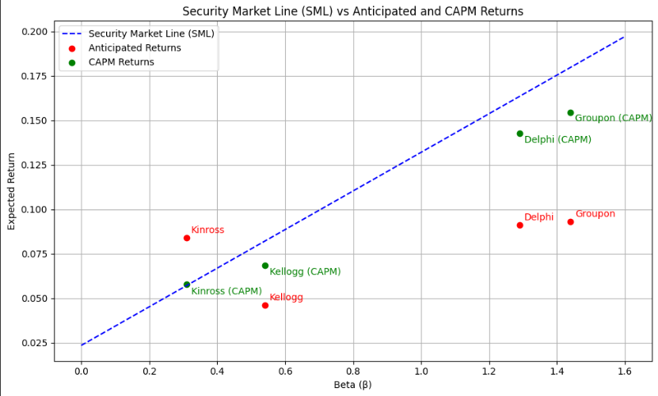

**2. How would you characterise the riskiness of the different stocks being**

**considered by the Cavalier Fund? Which stock do you believe is the**

**riskiest, and which is the least risky?**

The Cavalier Fund is considering investments in four companies—Delphi Automotive, Groupon, Kellogg, and Kinross Gold. Each of these stocks comes from a different sector and carries a unique level of risk.

**Delphi Automotive**, part of the auto parts industry, has a fairly high beta of 1.29. This means its returns tend to move more sharply than the overall market. Despite that, its standard deviation is 24.6%, which isn’t extreme. This combination suggests that while Delphi is moderately sensitive to market fluctuations, it maintains a reasonable level of volatility. That makes it a relatively balanced investment offering the potential for good returns without excessive risk.

**Groupon**, on the other hand, stands out for its high risk. It has the highest beta (1.44) and the highest standard deviation (67.1%) of all four stocks. These figures point to significant volatility and strong reactions to market movements. In recent years, its performance has been inconsistent, further reinforcing its profile as a speculative and high-risk option. Among all the stocks, Groupon clearly carries the most risk.

**Kellogg**, from the processed food sector, is the most stable of the group. With the lowest beta (0.54) and lowest standard deviation (14.6%), it’s largely unaffected by market swings. This stability makes it a classic low-risk, defensive stock—well-suited for cautious investors or portfolios aiming for steady, long-term growth with minimal exposure to risk.

**Kinross Gold** presents a more complex risk profile. Its beta is just 0.31, implying it doesn’t move much with the broader market. However, it has a very high standard deviation (65.0%). That’s because its performance is heavily tied to gold prices, which can be highly unpredictable. While it’s not very correlated with the market, it is still quite volatile—making it a risky choice in terms of total return fluctuation.

**CONCLUSION**

Groupon is the most risky stock due to its high beta and extreme volatility. Kellogg is the safest, with minimal market exposure and steady performance. Delphi offers a reasonable trade-off between risk and return, while Kinross is highly volatile due to its exposure to gold prices, despite having a low beta.

**3. How does portfolio diversification effect your characterisation of risk for**

**the stocks?**

Portfolio diversification plays a critical role in how we assess the risk of individual stocks. While evaluating stocks such as Delphi, Groupon, Kellogg, and Kinross Gold, it's important to distinguish between two types of risk:

**Systematic Risk** (measured by **beta**):

* This is market-wide risk that cannot be diversified away.
* All stocks are affected by this to some extent (e.g., recessions, inflation).

**Unsystematic Risk** (company- or sector-specific risk):

* This includes risks unique to a specific firm or industry.
* This risk **can be reduced or eliminated** through diversification.

In a well-diversified portfolio, the total ups and downs (measured by standard deviation) of individual stocks matter less. What becomes more important is **beta**, which shows how much a stock moves with the overall market.

Diversification helps investors cancel out those company-specific risks by spreading investments across different stocks. That way, the main risk they need to worry about is the general market risk, which is what beta measures.

So, for the Cavalier Fund, when building a portfolio of different stocks, it makes more sense to look at each stock’s **beta** to understand how much it adds to the overall market risk of the portfolio, rather than focusing only on how much that stock's price changes on its own.

**4. Kramer argues that the returns associated with a 50-50 weighted portfolio**

**of Groupon and Kinross Gold have a lower standard deviation than those**

**associated with either Groupon or Kinross Gold stock alone. Is that true?**

Portfolio Standard Deviation Formula (2 Assets):

σp = √[ (w1² * σ1²) + (w2² * σ2²) + 2 * w1 * w2 * σ1 * σ2 * ρ12 ]

Where:

* w1, w2: weights of the two assets
* σ1, σ2: standard deviations of the two assets
* ρ12: correlation coefficient between the two assets
* σp: portfolio standard deviation

Given:

* σ (Groupon) = 0.671
* σ (Kinross) = 0.650
* w1 = w2 = 0.5

**Case 1:** Perfect Positive Correlation (ρ = +1)

σp = √[ (0.5² * 0.671²) + (0.5² * 0.650²) + 2 * 0.5 * 0.5 * 0.671 * 0.650 * 1 ]

= √[0.1125 + 0.1056 + 0.2183] = √0.4364 ≈ 0.6606

**Case 2:** Zero Correlation (ρ = 0)

σp = √[0.1125 + 0.1056 + 0] = √0.2181 ≈ 0.4668

**Case 3:** Perfect Negative Correlation (ρ = -1)

σp = √[0.1125 + 0.1056 - 0.2183] = √0 = 0

**CONCLUSION**

**Kramer’s claim is conditionally true.**

* If Groupon and Kinross returns are not perfectly correlated, the 50-50 portfolio will have lower standard deviation than either stock alone.
* But if the two are highly positively correlated, the reduction in risk is small and the portfolio could still be riskier than Kinross alone.

**5.What is the argument for Kinross Gold?**

Kinross Gold may seem like a risky investment at first glance. It has a high standard deviation (65%), which means its returns can fluctuate a lot. However, when we look at how it behaves in a broader portfolio, it becomes a more attractive choice.

Rather than focusing only on expected return, it's important to consider how much risk you take to get that return. This is called risk-adjusted performance. Tools like the Sharpe Ratio help us compare different investments on this basis. While Kinross Gold doesn’t have the highest return, it offers a reasonable return for the risk involved.

What really makes Kinross Gold valuable is its diversification benefit. When you combine it with other stock, especially those from very different industries, it can actually reduce the overall risk of the portfolio. For example, a 50-50 portfolio of Kinross and a tech stock like Groupon can have a lower combined risk than investing in either one alone. This is because their returns don’t move in the same direction at the same time, which smooths out the ups and downs.

Looking at a stock in isolation doesn’t give the full picture. Even if Kinross looks too risky on its own, it adds stability when mixed with other investments. This is especially true because it operates in the gold sector, which often performs differently from the rest of the market.

In conclusion, Kinross Gold might not be the best choice as a standalone investment, but within a well-diversified portfolio, it plays an important role. It helps reduce total risk and adds balance, making it a smart strategic choice for long-term investors.

**6.How should investors price risk? How should they trade off the relation**

**between risk and return?**

Investors price risk by demanding higher expected returns for taking on greater uncertainty. This relationship is the foundation of modern finance and is captured by models like the Capital Asset Pricing Model (CAPM).

**Expected Return= Risk-Free Rate + β × ( Market Return − Risk-Free Rate )**

Here, beta reflects how much a stock’s returns move with the market. A higher beta means more risk and, therefore, a higher return is required to justify the investment.

Investors should aim to maximize their return for a given level of risk or minimize risk for a given level of return.

1. **Conservative investors** may prefer low-beta, stable assets with predictable returns, such as government bonds or defensive stocks.

Example: **Kellogg**

* **Beta:** 0.54 (low sensitivity to market movements)
* **Standard Deviation:** 14.6% (lowest among all four)
* **Anticipated Return:** 4.6%
* **Sharpe Ratio:**0.15 ( Moderate )

Kellogg is a defensive stock from the consumer staples sector. Its lower beta and volatility make it ideal for investors who want to preserve capital and avoid large swings in value.

1. **Aggressive investors** may choose higher-beta, volatile assets that offer the chance for greater returns, but also carry more risk.

Example: **Groupon**

* **Beta:** 1.44 (highest in the group; very sensitive to market changes)
* **Standard Deviation:** 67.1% (highest volatility)
* **Anticipated Return:** 9.3%
* **Sharpe Ratio:** Lowest among all

Groupon’s returns are highly volatile and unpredictable, but it offers a chance for strong gains in bullish markets. It suits risk-tolerant investors seeking growth and speculation opportunities.

**CONCLUSION**

The key is to evaluate investments based on risk-adjusted performance. Metrics like the Sharpe Ratio help here by measuring how much excess return an investor receives per unit of risk. A higher Sharpe Ratio indicates a more attractive investment on a risk-return basis.

**7. What is the risk-adjusted benchmark return on the S&P 500 portfolio? On**

**the proposed stocks?**

The Sharpe Ratio is a measure of risk-adjusted return. It evaluates how much excess return you receive for the extra volatility you endure for holding a riskier asset.Higher the Sharpe ratio better is the stock to invest in.

Formula:

**Sharpe Ratio = (Rp - Rf) / σp**

Where:

* • Rp : Portfolio return
* • Rf : Risk-free rate (e.g., yield on 3-month T-bills)
* • σp : Standard deviation of portfolio returns

|  |  |  |  |  |  |
| --- | --- | --- | --- | --- | --- |
| **Stock** | **Anticipated Return** | **Std Dev (σ)** | **Beta (β)** | **CAPM Return** | **Sharpe Ratio** |
| **Delphi** | 9.1% | 24.6% | 1.29 | 14.28% | 0.27 |
| **Groupon** | 9.3% | 67.1% | 1.44 | 15.46% | 0.10 |
| **Kellogg** | 4.6% | 14.6% | 0.54 | 6.83% | 0.15 |
| **Kinross** | 8.4% | 65.0% | 0.31 | 5.77% | 0.09 |
| **S&P 500** | 60.3% | 21.8% | 1.00 | N/A | 0.37 |

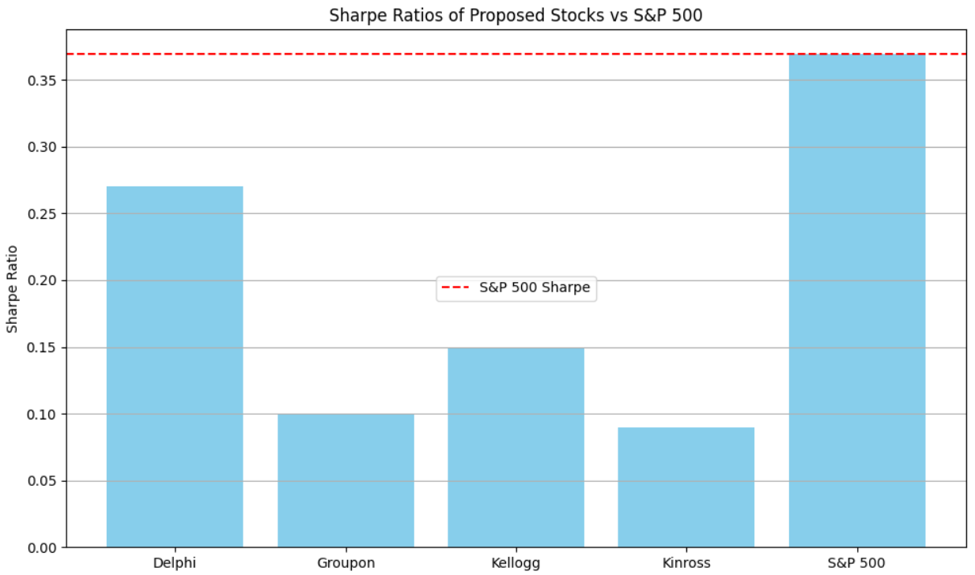

**CONCLUSION**

* S&P 500 has the highest Sharpe Ratio (0.37), indicating the best return per unit of risk.
* Delphi follows with a decent Sharpe Ratio (0.27).
* Groupon, Kellogg, and Kinross show much lower Sharpe Ratios, suggesting they offer lower returns relative to the risk taken.

**8. How should Nickerson think about picking stocks for the Cavalier Fund?**

Daniel Nickerson, as the Senior Portfolio Manager of the Cavalier Fund, should approach stock selection using a holistic, risk-adjusted strategy grounded in both quantitative metrics and fundamental analysis.

* **Apply Risk-Adjusted Metrics (Sharpe Ratio and CAPM):**Nickerson should rely on objective measures like the Sharpe Ratio and CAPM returns to assess whether a stock provides appropriate compensation for its level of risk.
  + Stocks with actual return above CAPM return may be undervalued (good picks).
  + A high Sharpe Ratio indicates efficient use of risk in generating returns.

* **Favor Delphi for Strong Risk-Return Balance:**
  + **Anticipated Return:** 9.1%
  + **Standard Deviation:** 24.6%
  + **Sharpe Ratio:** 0.27 (highest among the group)

Delphi provides a solid balance between expected returns and volatility. It also outperforms its CAPM benchmark, signaling good relative value.

* **Include Kellogg for Portfolio Stability:**
  + **Anticipated Return:** 4.6%
  + **Standard Deviation:** 14.6% (lowest)
  + **Beta:** 0.54

Kellogg is a low-risk, stable stock. Though its return is modest, its consistent performance and defensive nature make it a great stabilizer in a diversified portfolio.

* **Consider Kinross for Diversification Benefits:**
  + Alone, Kinross has high volatility (65%) and a low Sharpe Ratio (0.09).
  + However, its low correlation with market and tech stocks makes it ideal for reducing total portfolio volatility.

A 50-50 portfolio of Kinross and Groupon lowers standard deviation more than either stock individually.

* **Be Cautious with Groupon Unless Paired:**
  + Groupon has highest beta (1.44) and extreme volatility (67%).
  + Despite a decent return (9.3%), it’s highly risky.

Only consider it if paired with low-correlation assets like Kinross.

### **CONCLUSION**

Nickerson should build a diversified portfolio by mixing efficient performers (Delphi), defensive assets (Kellogg), and diversifiers (Kinross), while being cautious with speculative picks like Groupon unless risk is offset.

**OPTIMAL PORTFOLIO CONSTRUCTION ANALYSIS**

**OBJECTIVE**

To construct an optimal portfolio of four stocks—Delphi, Groupon, Kellogg, and Kinross Gold—by identifying the portfolio with the maximum Sharpe Ratio, achieving the best balance between return and risk (volatility).

# **APPROACH**

**GIVEN DATA**

|  |  |  |  |
| --- | --- | --- | --- |
| **Stock** | **Anticipated Return** | **Standard Deviation (σ)** | **Beta (β)** |
| Delphi | 9.1% | 24.6% | 1.29 |
| Groupon | 9.3% | 67.1% | 1.44 |
| Kellogg | 4.6% | 14.6% | 0.54 |
| Kinross | 8.4% | 65.0% | 0.31 |

**CORRELATION MATRIX ( DEFINED MANUALLY )**

|  |  |  |  |  |
| --- | --- | --- | --- | --- |
|  | **Delphi** | **Groupon** | **Kellogg** | **Kinross** |
| **Delphi** | 1.00 | 0.20 | 0.10 | 0.05 |
| **Groupon** | 0.20 | 1.00 | 0.10 | 0.30 |
| **Kellogg** | 0.10 | 0.10 | 1.00 | 0.05 |
| **Kinross** | 0.05 | 0.30 | 0.05 | 1.00 |

**CALCULATION**

Computed from the correlation matrix and standard deviations using the formula:  
 **Cov_ij = ρ_ij × σ_i × σ_j**

**PORTFOLIO GENERATION**

Created all possible combinations of weights (in 5% intervals) across the four stocks such that the total weight = 1. Each combination represents a unique asset allocation portfolio.

3. 4. Portfolio Metrics Computed

* **Expected Portfolio Return:** Weighted average of individual stock returns.
* **Portfolio Variance:**

Var_p = wᵀ × Σ × w

* **Portfolio Standard Deviation (Volatility):** Square root of variance.
* **Sharpe Ratio:**

Sharpe = (E[R_p] - R_f) / σ_p (R_f = 2.34%)

**OPTIMISATION**

Identified the portfolio with the maximum Sharpe Ratio. This is the most efficient portfolio, offering the highest return per unit of risk.

**VISUALISATION**

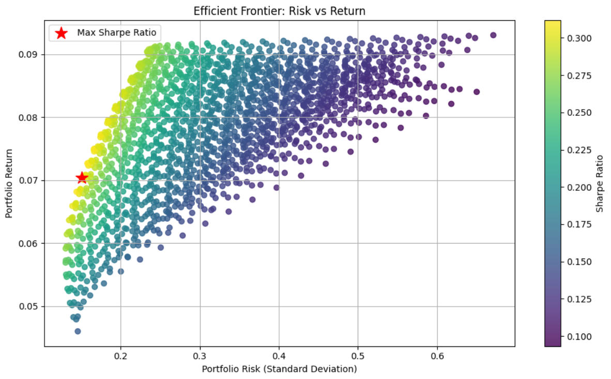

# **OUTCOME**

**Optimal Portfolio weights**

|  |  |
| --- | --- |
| **Stock** | **Weight** |
| **Delphi** | 0.50 (50%) |
| **Groupon** | 0.00 (0%) |
| **Kellogg** | 0.45 (45%) |
| **Kinross** | 0.05 (5%) |

**Interpretation:**

* **Delphi (50%)** is the core holding due to highest Sharpe Ratio (0.27)
* **Kellogg (45%)** is included for low volatility (14.6%) and diversification benefit.
* **Kinross (5%)** is a small holding for diversification, despite high volatility (65%).
* **Groupon (0%)** is excluded, due to its high volatility and low Sharpe Ratio (0.10).

# **CONCLUSION**

The resulting optimal portfolio is best suited for maximizing returns at a given risk level and supports rational asset allocation for the Cavalier Fund..